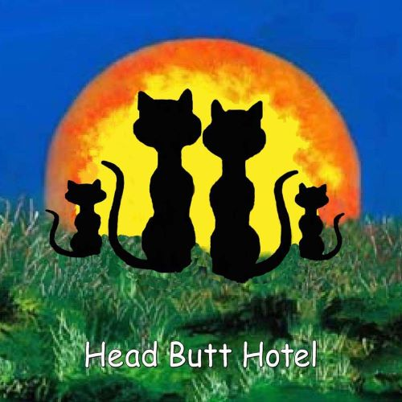

Head Butt Hotel
1336 Poole Street, North Myrtle Beach SC 29582
◊ Phone: Christine Zois (973) 619 2956 ◊
Email: Christine@Headbutthotel.org

ADOPTION CONTRACT

Animal’s Name: Description: Sex: ________

Date of birth / Age: _ __ Id#: ______ Microchip # ___________________

======================================================================

Adopter’s name: Phone Number: __________________________

Address: __________________________ City: ______________ State: _____ Zip: ______

Email Address: _____________________________________________________________

Driver’s License # ________________________________________ State: _________

I, ____________, agree that I am adopting the above-mentioned animal(s) solely for me and my immediate family as a pet. I agree that I will not abandon, sell, give away, or dispose of the animal(s) to another party, for any reason whatsoever.
Initial: _______

Donation: I understand that my adoption donation of $ _______ is nonrefundable and is used by the Head Butt Hotel to defray the costs of food, shelter, titer testing, veterinary care, and spaying/neutering. Additional donations are greatly appreciated, and any expenses for transport arrangements are separate and additional.
Initial: ______

Return Policy: I agree that if I am no longer able or willing to take care of the animal (s), for any reason whatsoever, inclusive of any possible and or future health issues which could result in the euthanasia of this pet(s), premature, unnecessary, unwarranted, or otherwise, I will first contact an authorized representative of the Head Butt Hotel, to reclaim the animal (s). HBH will respond and arrange pick up / meeting location no later than 14 days from my request. I understand that I am responsible for the care of the animal(s) until it has been delivered safely to a representative of the Head Butt Hotel, together with the original and current veterinary records. The adopter consents to reclamation of this animal(s), by the HBH at any time, for whatever reason, and/or failure to comply with the terms of this contract.

Initial: __ ______

Proper Care. I agree to take care of the animal(s) in a responsible and humane manner, providing adequate food, shelter, water, grooming, and veterinary care. To optimize the health of this animal, I agree to continue with the established nutritional regimen, which has been provided.

I assume full responsibility for its’ wellbeing, providing adequate and wholesome food and fresh water, shelter from weather, and any veterinary care needed to provide for the continued wellbeing of this animal.
Initial: __ _____

I agree that under NO circumstances, is this cat to ever be administered any of the following pharmaceutical products for which the risks outweigh benefits: Metronidazole, Convenia, Gabapetin, and all antibiotics classified as Fluoroquinolones. These are commonly administered without pet owners being furnished Informed Consents and often lead to irreversible health conditions.
Initial: __________

I agree to allow an authorized representative to follow-up either in person or by telephone and for the first year from adoption date, we would like to receive quarterly updates including pictures to ensure this is a good match for both the client and pet.
Initial: __________

This animal (if canine) will not, under any circumstances, be left outdoors unattended to, given the extreme danger that exists with regard to the theft of animals to be used for bait and fighting. I further agree to comply with all state and county legal and licensing requirements in the residing state. Felines are strictly indoor only pets.
Initial: __________

Vaccinations. This pet is being furnished with a current Rabies Vaccination or a Titer test. To comply with the South Carolina Rabies Statute which requires continuous protection of pets, we check titers in 3 yr. intervals, being there is no difference between the 1 and 3 yr. vaccinations besides the # printed on the manufacturer label. I agree that under NO circumstances, will I consent or allow any veterinarian in any state, to proceed with any further vaccinations regardless of county or state statutes, unless a titer blood test which can be done as part of the annual wellness exam with Kansas State Veterinary Diagnostic Laboratory or HemoPet reveals a 0.0 reading indicating an additional booster is necessary. I understand that even a second blindly administered vaccination, constitutes a vaccination overdose which will ultimately result in serious implications, detrimental to the health of this pet. Once the titer test has been completed, if the results reveal, that this pet in fact requires an additional booster at some point during their lifetime, I agree to have ONLY a Merial Pure Vax feline 3 year non- adjuvanted rabies booster administered.
Initial: __________

I further understand that it is my right as a pet owner to never consent to a second rabies vaccination for indoor only cats, regardless of the titer results, as this substantially increases the chances of this pet having an avoidable cancer diagnosis. The arbitrary state levels established are just that, ARBITRARY and there is no scientific data to back up the 0.50 limit as the required level to provide continuous protection. A pet either has immunity protection even with a 0.01 reading once previously vaccinated, or it has a 0.0 reading if never having previously been vaccinated.
Initial: _ _____

Vaccination Addendum: As a result of our lifetime warranty to provide for the return of this pet to our care, regardless of any possible health issues, I agree NOT to allow this cat to ever be rabies vaccinated subsequently being an indoor only pet. I further agree that if you choose not to continue with our designated vet, Animal Hospital of South Carolina, to continue overseeing any and all future care this pet may require, your vet will be required to countersign and agree to all terms of this adoption contract.

Initial: __________

Declawing. I agree that I will not declaw the animal (s) under any circumstances.

Initial: __________

Animal Welfare Violations. I certify that no member of my household has been convicted of an animal welfare law violation, including but not limited to cruelty, abandonment, or neglect.

Initial: __________

No Representations. I understand that the Head Butt Hotel does not make any warranties, expressed or implied, on the temperament, behavior, or health of the animal (s). I agree to absolve the Head Butt Hotel and its’ authorized representatives, from any liability, damages, or injury caused by the animal(s).
Initial: __________

The foster / adopter shall quarantine this pet from other animals for a period of two weeks. The adopter absolves the Head Butt Hotel and its’ authorized representatives, from liability for the transfer of any disease/condition of the dog/cat to any person or any other animal during or at any time after this period. The adopter further indemnifies the Head Butt Hotel and its’ authorized representatives against all medical and/or veterinary costs relating to the transfer of any disease/condition to any person or other animal.
Initial: __________

The foster / adopter indemnifies the Head Butt Hotel and its’ representatives, from any responsibility for this animal, directly or indirectly, for veterinary expense, mortality, allergy, or any other condition resulting from contact with the said animal, actions of said animal, or for any other reason(s). The foster / adopter further indemnifies the Head Butt Hotel, its’ directors, officers, and volunteers, against all claims, known or unknown, now or hereafter, arising in connection with this animal. The adopter agrees to reimburse the HBH for all expenses, including court costs and attorney fees, incurred in enforcing the terms and provisions of the contract. This is above and beyond our established $5000 non-compliance penalty fee. The laws of the State of South Carolina shall apply to any dispute arising out of this contract.
Initial: __________

I certify that I have read and fully understand the terms of this agreement and that I will comply with the same. I agree that the HBH and its’ authorized representatives have the right to reclaim the animal(s) if I fail to comply with any of the terms of this agreement, if any statements made by me are untrue, and /or if my check for the adoption donation is returned. I certify that I am at least 21 years and I acknowledge receipt of custody of this pet(s) from the Head Butt Hotel.

Signature Adopter / Date

Head Butt Hotel / Date

Veterinary Name with License #

Veterinary Address

Veterinary Signature / Date

